VAVILOV SOCIETY OF GENETICISTS AND BREEDERS  OF UKRAINE | UMAN  NATIONAL UNIVERSITY OF HORTICULTURE
NATIONAL
DENDROLOGICAL PARK “SOFIYIVKA” OF NAS OF UKRAINE

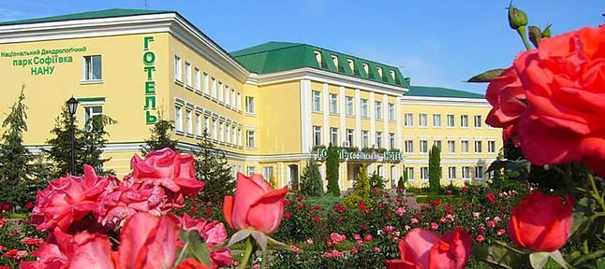

The Third International Scientific Conference
"ETHNOBOTANIC TRADITIONS IN AGRONOMY, PHARMACY AND GARDEN DESIGN", dedicated to the INTERNATIONAL YEAR OF PLANTS HEALTH

July 6-9, 2020

The Conference networks:

1. Ethnobotany as a component of ethnocultural traditions that determine the cultural identity of civilized people.
2. The meaning of ethnic names for the botanical systematics of vascular plants.
3. Native and alien plants in traditional and folk medicine, cosmetics, cooking and garden design.
4. In situ and ex situ biotic diversity preservation.
5. The role of botanical institutions in fostering an environmentally oriented mentality.
6. Effectiveness of preventive measures against invasion.
7. Didactic issues on ethnobotanical theory and practice.
8. Ethnobotanical motifs in music works and literature.

Working languages: Ukrainian, English and Russian.

Organizing committee:

I. Kosenko – D.Sc. in Biology, Professor, Corresponding member of NAS of Ukraine, Uman (the Head);
V. Kunakh – D.Sc. in Biology, Professor, Corresponding member of NAS of Ukraine, Kyiv (the Co-Head);
S. Klymenko – D.Sc. in Biology, Professor, Corresponding member of NAS of Ukraine, Kyiv (the Co-Head);
A. Balabak – D.Sc. in Agriculture, Professor, Uman;
O. Balabak – D.Sc. in Agriculture, Senior researcher, Uman;
V. Hrabovyi – Ph.D. in Biology, Senior researcher, Uman (the Vice-Head);
I. Didenko – Ph.D. in Biology, Uman;
H. Muzyka – Ph.D. in Biology, Senior researcher, Uman;
A. Opalko – Ph.D. in Agriculture, Professor, Uman;
O. Opalko – Ph.D. in Agriculture, Associate Professor, Uman;
V. Polischuk – D.Sc. in Agriculture, Professor, Uman;
T. Sedelnikova – D.Sc. in Biology, Senior researcher, Krasnoyarsk, Russian Federation;
V. Sichkar – D.Sc. in Biology, Professor, Odesa;
M. Fedorchuk – D.Sc. in Agriculture, Professor, Mykolayiv;
S.V.S. Chauhan – Ph.D., D.Sc. in Botany, Academy of Life Sciences, India;
T. Shvets – Ph.D. in Biology, Uman;
A. Yatsenko – D.Sc. in Agriculture, Professor, Uman;
V. Oksantiuk – Ph.D. in Biology, Uman (Secretary).

Guidelines for authors to prepare manuscripts:
Manuscripts presented for publication cannot exceed five pages in length, including tables, illustrations and references. References should be formatted according to the APA Style rules, and all recoverable resources cited in the text must be included in the reference list. Your manuscript should be in Microsoft Word for Windows (file in doc- or docx format), font Times New Roman, 14 pt, single space, single column with 2.0 cm all margins on the A4 (210 x 297 mm) paper size. Manuscripts which do not meet the conference scopes will be declined and the conference organizing committee will inform the authors about it. The manuscript (text with figures and tables and figures as separate jpg-format files) should be sent to email: etnobotany@ukr.net

PARTICIPATION FEE
Foreign scholars do not pay participation fee.
Participants pay for travelling, accommodation, meals, international phone call, fax etc. by themselves.

Address for correspondence:
National Dendrological Park "Sofiyivka" of NAS of Ukraine, 12-а, Kyivska St., Uman, Cherkasy region, 20300, Ukraine
Tel.: (+38-047-44) 3-63-19; (+38-096) 6102846; (+38-050) 6116881

Deadline for registration and manuscripts submission is June 10, 2020.
The following participation form should be sent with the Conference materials:

First name______________________________________
Last name________________________________________
Academic degree_______________________________
Position_______________________________________
Affiliation ___________________________________
Form of participation: in personal, remote_____________
The theme of presentation_________________________
Section №_____________________________________
Mailing address_________________________________
Tel.:_________________________________________
E-mail________________________________________
Departure/arrival dates___________________________

ATTENTION:
The full texts of reports prepared in accordance with the requirements of the peer-reviewed scientific online journal of the National Dendrological Park "Sofiyivka" of the NAS of Ukraine "Journal of Native and Alien Plant Studies" will be published free of charge until December 2020. The authors ' guide is attached (see http://mchr.sofievka.org/about/submissions#authorGuidelines).

Sincerely,
the conference Organizing Committee!

